End User Training Guide

**GMS-Application**

**Created for :** CIRM – GMS Application Creation

**Prepared for :** CLIN-2 Application Creation

**Date of Preparation :** July 14, 2023

**Status :** Done

User to Enter the valid **Url:** [**https://test-grants.cirm.ca.gov/login/login**](https://test-grants.cirm.ca.gov/login/login)

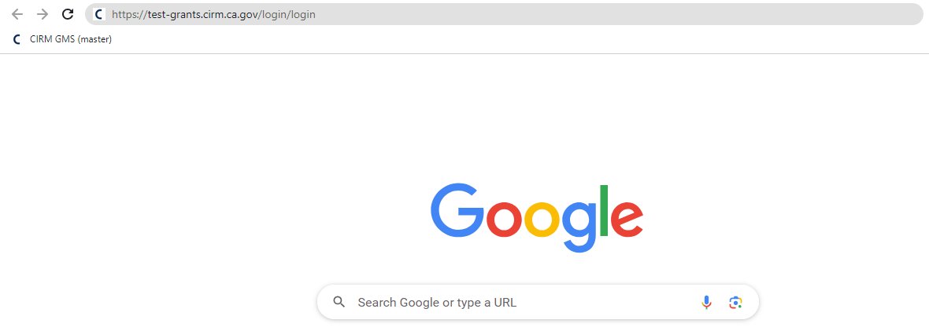

User should be able to see the Login Page of **CIRM – GMS Application**

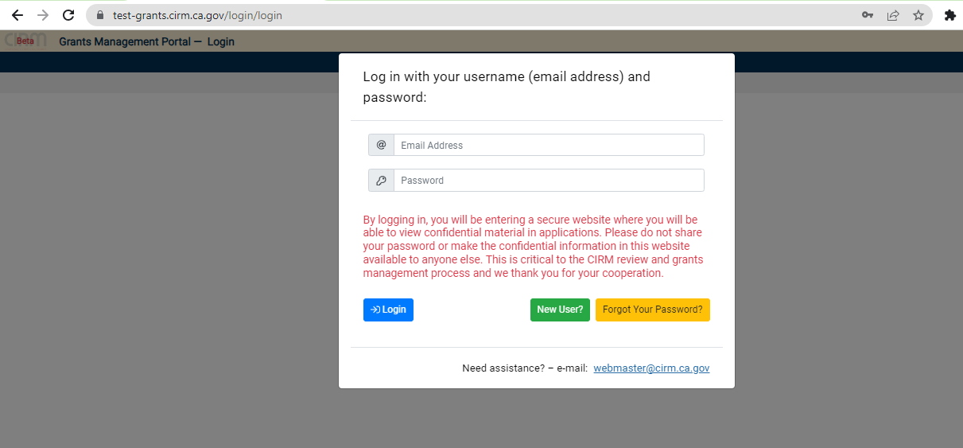

User should be able to enter the credentials of GMS Application and click the **Login Button**

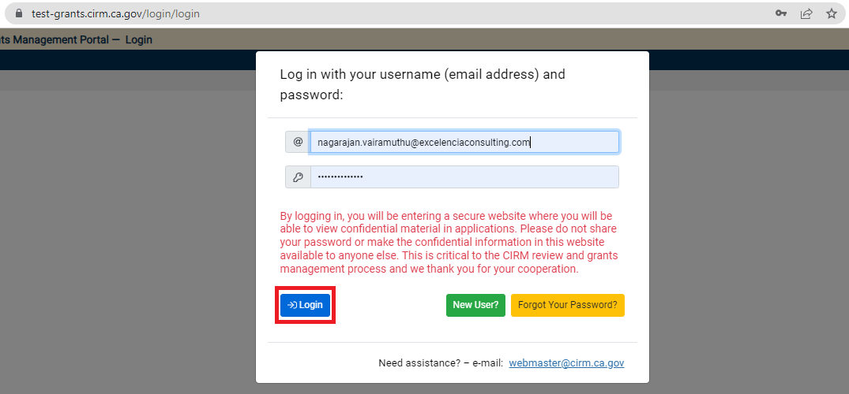

Weather check It navigate to the Valid User

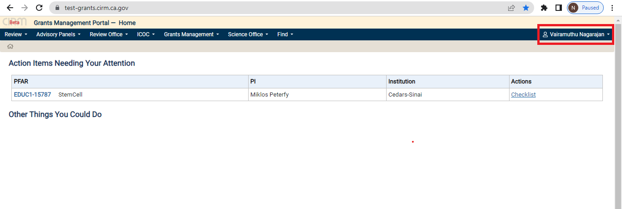

Login with Valid Username & Valid Password, Navigate to the Home page.

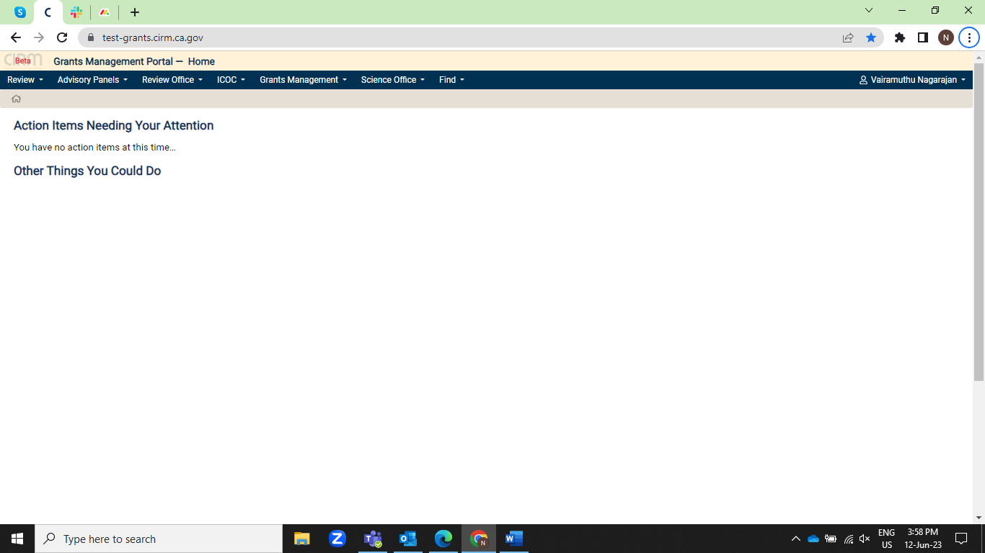

Click the “Find” and click the “Users”.

Search “Users” using with “Last Name” and click the “Find User’s”. Navigate to the Respective Page.

Select the “PI” and click the “Sign In” Arrow.

Click the “Open Program” in Dashboard.

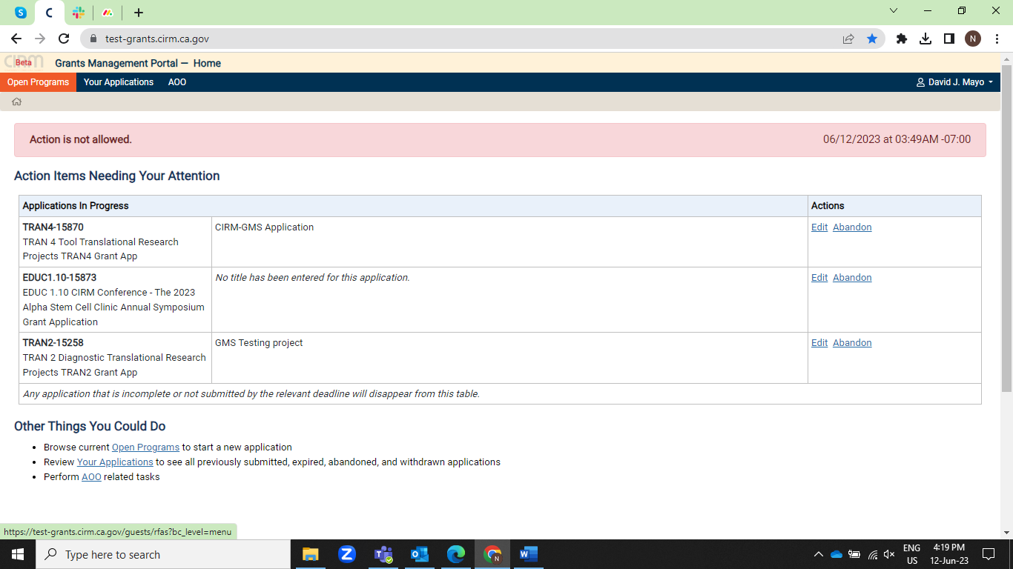

Click the “CLIN2” in the dashboard page.

Navigate to the Respective page.

Click “Eligibility” in Left menu, 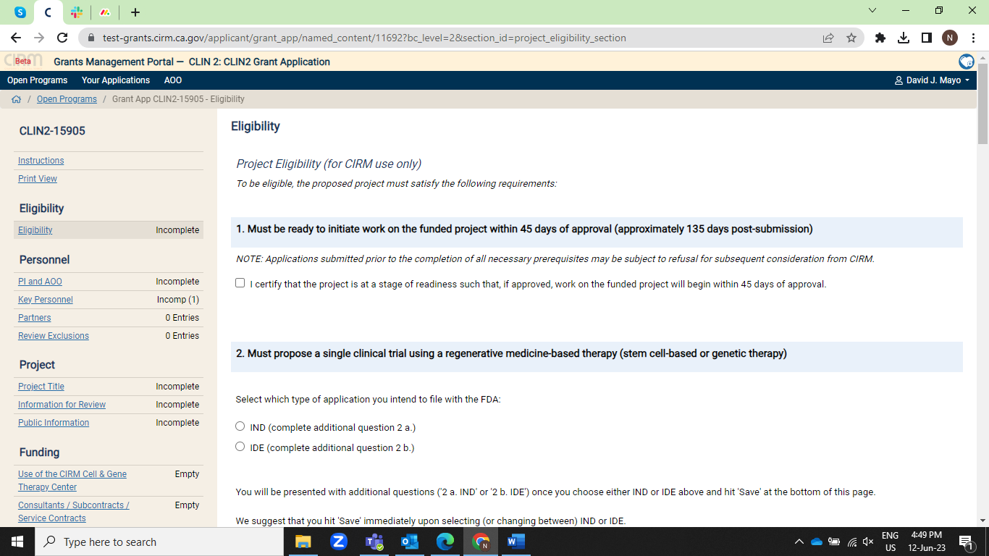

Fill all the “Eligibility options” in Eligibility module.

After Fill all options in Eligibility, Click the “Save button” in the bottom of the page.

Click the “PI and AOO” in left menu, Navigate to the respective page.

Fill the Percentage & Description in PI, Click the “Save button”.

Add the “AOO” for this Project in “Dropdown” and click the “Save Button”.

Click the “Partners” in Left menu, fill all the partners and click the “Save Button”.

Click the “Review Exclusions” in left menu, fill the details and Click the “Save Button”.

Click the “Project Title” in left menu, in left menu, fill the details and click the “Save Button”.

Click the “Information for Review” in left menu, fill the details and Click the “Save Button”.

Click the “Public information” in left menu, fill the details and Click the “Save Button”.

Click the “Use of the CIRM Cell & Gene Therapy Center**”** in left menu, select the check box and click the “Save Button”.

Click the “Consultants / Subcontracts / Service Contracts” and click the “ADD Consultants/Subcontracts/Service Contracts”.

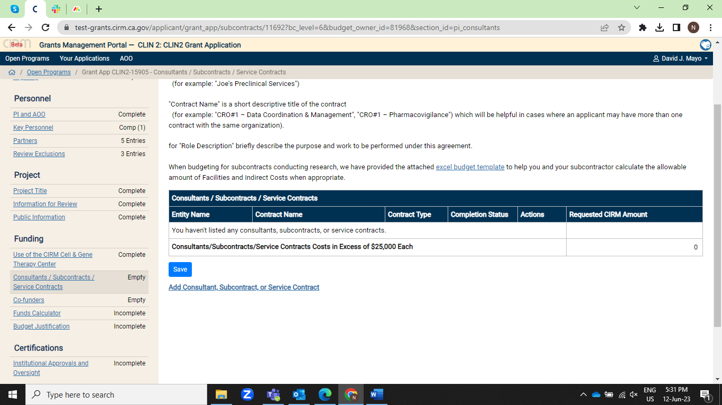

Fill the “Con/Sub/Ser”, Click the “Save Button”.

Add the “Amount” in Created “Con/Sub/Ser”. Click “Save Button”.

Click the “Co-funder”, in the left menu, Click the “Add Co-funder”

Fill the “Organization Name”, Click the “Save Button”.

Enter the “Co-funding Amount”.

Click the “Funds Calculator” in the left menu.

Enter the Value’s and percentage in the respective field, Click the “Save Button”.

Click the “Budget Justification” in left menu, Fill all the field in budget justification, Click the “Save button”.

Click the “Institutional Approvals and Oversight” in the left menu.

Fill all the field in “Institutional Approvals and Oversight” Click the “Save Button”.

Click the “Document Uploads” in the left menu.

Upload the “File in pdf, xlsx”.

Upload the File.

Click “Submit Button” in the left menu.

Click the “OK Button”.

Back to the “Find User’s” Page, So Login to the Our own login.

Find the “AOO” with the use of “Last Name” of “AOO”, and click “Find User’s”.

Click the “Login Icon” to Login the “AOO”.

Click the “Edit” in the “CLIN2-Form Number” in Dashboard.

” AOO” Review the “PI” and “Submit” / “Return” Application.

Submit the Application, when clicking the “Submit” button.

Then open our own username.

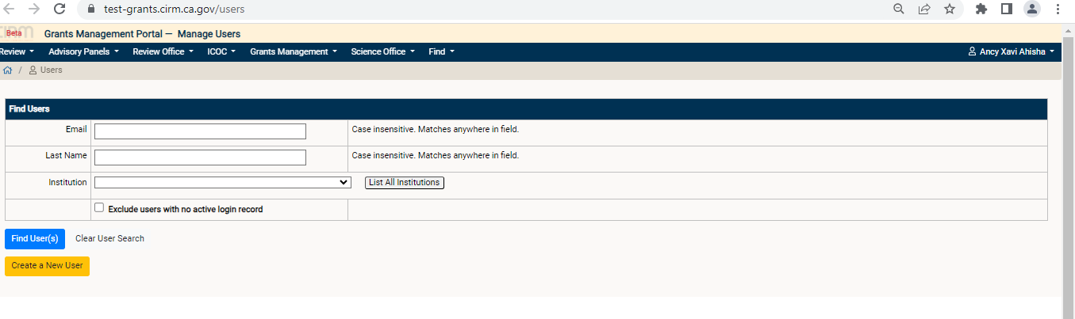

Click on Find and select Grant Application

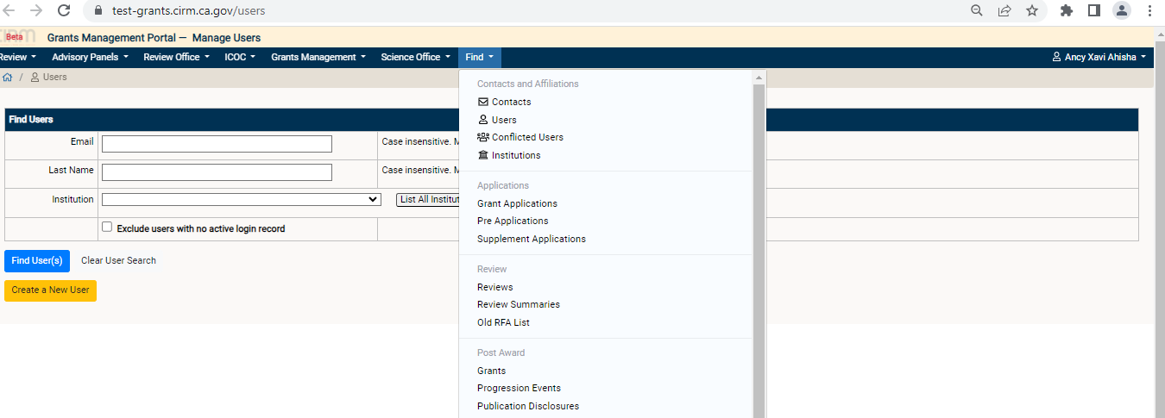

Select all the details.

Click on Apply Filter

Check whether the application number is available in the table.

Once it is available then the application is successfully submitted by PI and AOO.